**/* 1. Write a Java Program to print your Name entered through the command line as an argument. */**

public class Name {

public static void main(String args[]) {

System.out.println("Name : Gokul Sarkar \nRoll : 46");

System.out.println("The Name is :");

for (int i = 0; i < args.length; i++) {

System.out.println(args[i]);

}

}

}

**Output:**

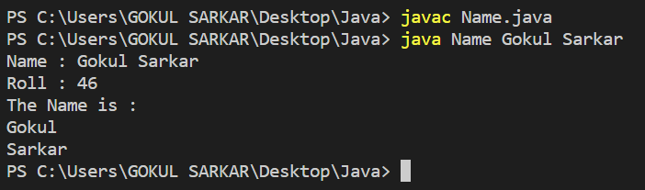

**/* 2. Write a Java program to convert Temperature from Fahrenheit to Celsius and vice versa. */**

import java.util.Scanner;

public class Fahrenheittocelsius {

public static void main(String args[]) {

Scanner sc = new Scanner(System.in);

System.out.println("Name : Gokul Sarkar \nRoll : 46");

System.out.println("Enter temperature in Fahrenheit:");

float temperature = sc.nextFloat();

float celsius = toCelsius(temperature);

System.out.printf("%.02f Fahrenheit = %.02f celsius %n",temperature,celsius);

System.out.println("Enter temperature in Celsius:");

temperature = sc.nextFloat();

float Fahrenheit = toFahrenheit(temperature);

System.out.printf("%.02f celsius = %.02f Fahrenheit %n",temperature,Fahrenheit);

}

public static float toFahrenheit(float celsius) {

float Fahrenheit = 9*(celsius/5)+32;

return Fahrenheit;

}

public static float toCelsius(float Fahrenheit) {

float celsius = (Fahrenheit-32)*5/9;

return celsius;

}

}

**Output:**

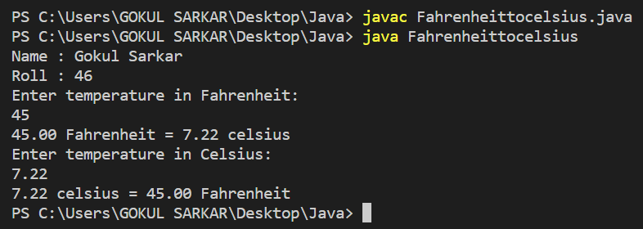

**/* 3. Write a Java program to add two numbers. */**

import java.util.Scanner;

public class Sum {

public static void main(String args[]) {

Scanner sc = new Scanner(System.in);

System.out.println("Name : Gokul Sarkar \nRoll : 46");

System.out.print("Enter the first number:");

int x=sc.nextInt();

System.out.print("Enter the second number:");

int y=sc.nextInt();

int sum=sum(x,y);

System.out.println("The sum of two numbers is:"+sum);

}

public static int sum(int a,int b) {

int sum=a+b;

return sum;

}

}

**Output:**

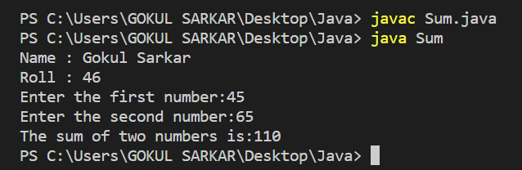

**/* 4. Write a java Program to find the area and Perimeter of a rectangle. */**

import java.util.Scanner;

public class Rectangle {

public static void main(String args[]) {

System.out.println("Name : Gokul Sarkar \nRoll : 46");

Scanner sc = new Scanner(System.in);

System.out.print("Enter length of rectangle : ");

int length = sc.nextInt();

System.out.print("Enter breadth of rectangle : ");

int breadth = sc.nextInt();

int perimeter = 2 * (length + breadth);

System.out.println("Perimeter of rectangle : "+perimeter);

int area = length * breadth;

System.out.println("Area of rectangle : "+area);

}

}

**Output:**

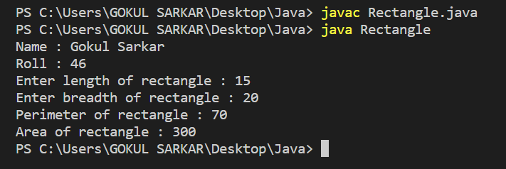

**/* 5. Write a program in Java to find the maximum of three numbers. */**

import java.util.Scanner;

public class Maximum {

public static void main(String args[]) {

System.out.println("Name : Gokul Sarkar \nRoll : 46");

Scanner sc = new Scanner(System.in);

System.out.print("Enter the first number:");

int a=sc.nextInt();

System.out.print("Enter the second number:");

int b=sc.nextInt();

System.out.print("Enter the third number:");

int c=sc.nextInt();

int largest;

if(a > b) {

if(a > c) {

largest=a;

}

else {

largest=c;

}

}

else if(b > c) {

largest=b;

}

else {

largest=c;

}

System.out.println("The maximum among three numbers is:"+largest);

}

}

**Output:**

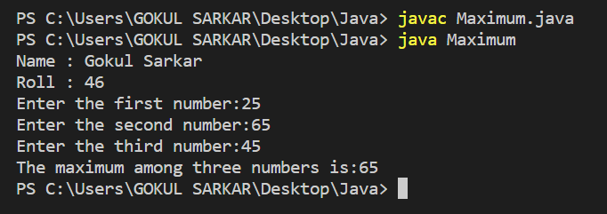

**/ *6. Write a Java Program to check whether a given year is a leap year. */**

import java.util.Scanner;

public class Leapyear {

public static void main(String args[]) {

System.out.println("Name : Gokul Sarkar \nRoll : 46");

int year;

System.out.println("Enter an Year:");

Scanner sc = new Scanner(System.in);

year = sc.nextInt();

if(((year%4==0)&&(year%100!=0))||(year%400==0)) {

System.out.println("The year is a leap year");

}

else {

System.out.println("The year is not a leap year");

}

}

}

**Output:**

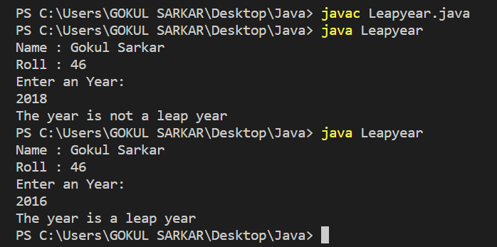

**/* 7. Create four dierent classes with three of them containing the function main.Save the file with a dierent name than that of the class name and run each of the classes with the main function. */**

class Hello1 {

public static void main(String[] args) {

System.out.println("Name : Gokul Sarkar \nRoll : 46");

System.out.println("Hello1 Class");

}

}

class Hello2 {

public static void main(String[] args) {

System.out.println("Name : Gokul Sarkar \nRoll : 46");

System.out.println("Hello2 Class");

}

}

class Hello3{

public static void main(String[] args) {

System.out.println("Name : Gokul Sarkar \nRoll : 46");

System.out.println("Hello3 Class");

}

}

class Hello4{

public static void main(String[] args) {

System.out.println("Name : Gokul Sarkar \nRoll : 46");

System.out.println("Hello4 Class");

}

}

**Output:**

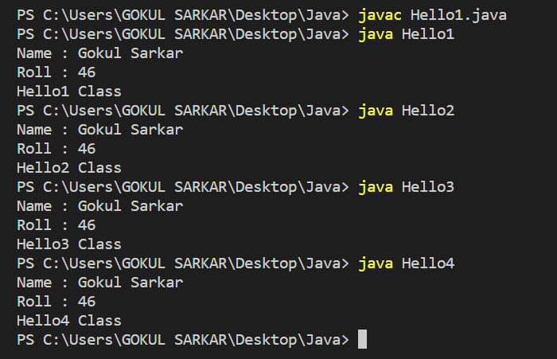

**/* 8. Write a java program to reverse a number entered as a command line argument. */**

public class Reverse {

public static void main(String args[]) {

System.out.println("Name : Gokul Sarkar \nRoll : 46");

int x = Integer.parseInt(args[0]);

int rev = 0;

while (x != 0) {

rev *= 10;

rev += x % 10;

x /= 10;

}

System.out.println("The Reverse of Given Number is:\t" + rev);

}

}

**Output:**

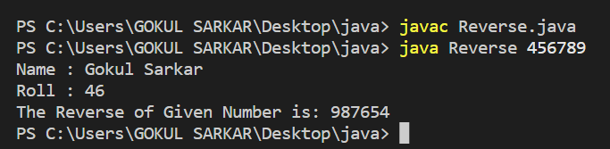

**/* 9. Write a java Program to count the number of digits entered through the command line argument. */**

public class NumberofDigits {

public static void main(String args[]) {

System.out.println("Name : Gokul Sarkar \nRoll : 46");

int num,count=0;

num=Integer.parseInt(args[0]);

while(num!=0) {

num/=10;

++count;

}

System.out.println("Number of digits:"+count);

}

}

**Output:**

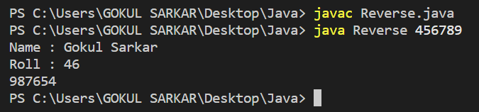

**/* 10. Write a java program to find all the multiples of 3 within a given range where the starting and ending value are entered through command line argument. */**

public class Multiples {

public static void main(String args[]) {

System.out.println("Name : Gokul Sarkar \nRoll : 46");

int num,i,j;

num=Integer.parseInt(args[0]);

j=Integer.parseInt(args[1]);

for(i = n;i<=j;i++){

if(i%3==0) {

System.out.println(i);

}

}

}

}

**Output:**

